

Report for Summer Training Program

On

**Closed loop temperature control**



DEFENCE LABORATORY JODHPUR

Defense Research and Development Organization (DRDO)

Ministry of Defense, INDIA

Prepared by: Under the guidance of:

Shashwat Lamba Shri Pankaj Agarwal Sc ‘F’ Bachelor of Engineering (BE) DRDO Jodhpur

Second Year (2nd Year)

Electronics & Communication (ECE)

MBM University, Jodhpur

**ACKNOWLEDGEMENT**

First and foremost, I would like to thank DLJ, DRDO for giving me the opportunity to intern at their esteemed organization. The experience and knowledge I have gained during this period have been invaluable and have greatly contributed to my social and professional development.

I am deeply grateful to my supervisors, Shri Pankaj Agarwal (Sc ‘F’), for their continuous support, guidance, and encouragement. Their expertise and insights have been instrumental in helping me understand the intricacies of my branch Electronics and Communication, and I am thankful for their valuable time and effort they’ve invested in mentoring me.

Additionally, I am thankful to my academic advisor, Shri Kapil Parihar (HOD ECE), for their constant support and for providing me with the necessary resources and guidance to excel in my internship.

Lastly, I would like to thank my colleagues and the technical staff at the DLJ premises for their unwavering support and encouragement throughout my internship journey.

Thank you

Shashwat Lamba

MBM University, Jodhpur

**Certificate**

This is to certify that Shashwat Lamba (24UECE7039) has successfully completed his internship at Defense laboratory Jodhpur, DRDO from 02/06/2025 to 16/07/2025.

During this period, he worked with the Camouflage department and was involved in the project Closed loop temperature control.

Shashwat Lamba demonstrated a high level of dedication, skill, and professionalism throughout the internship. He has shown ability to work effectively as part of a team and has made valuable contributions to our projects.

We wish him all the best in his future endeavors and believe that she will be an asset to any organization she chooses to be a part of.

Shri Pankaj Agarwal

Scientist F

DLJ, DRDO

**ABSTRACT**

The characteristics show that even for a small change in temperature the change in resistance of a thermistor is very large. The characteristics of thermistors are no doubt non-linear, but a linear approximation of the resistance temperature curve can be obtained over a small range of temperatures.

The setup with a heater, MOSFET, and microcontroller forms a closed loop system to accurately measure the temperature using a thermistor and construct a linearized temperature sensor. The key lies in controlling the heater to create known temperature points, measuring the corresponding thermistor resistance, and using this data to create a reliable temperature-to-resistance mapping for accurate temperature readings.

Heat is one of the most important considerations because it affects the performance and reliability of the parts and equipment as well as safety. Thermal resistance is the quantification of how difficult it is for heat to be conducted. Thermal resistance is represented as the quotient of the two points (amount of heat flow per unit time). This means that the higher the thermal resistance, the more difficult it is for heat to be conducted, and vice versa.

**INDEX**

|  |  |
| --- | --- |
| Index no. | Description |
|  | Acknowledgement |
|  | Certificate of Appreciation |
|  | Abstract |
|  | Index |
|  | Introduction |
|  | Open-loop and Closed-Loop Control system |
|  | Hardware programming |
|  | Arduino |
|  | MOSFET |
|  | Thermistor |
|  | Working Principle I |
|  | PWM Controller |
|  | PID Controller |
|  | Working |
|  | Working Principle II |
|  | Working Principle III |
|  | Operational Amplifier |
|  | LM-35 |
|  | Op-amp based closed loop temperature controller using Multisim |

**INTRODUCTION**

Defense Laboratory, Jodhpur (DLJ) was established in May 1959 to deal with the problems related to the environmental conditions in the desert and their impact on desert warfare. The initial charter allotted to the laboratory was, “Undertaking field trails on weapons and equipment which were either newly designed or developed in the country or were being manufactured indigenously with imported know-how, besides conducting basic research as applicable in the arid zone, physiological studies, Radio-wave propagation studies and solar energy.”

Subsequently, with the expansion of the laboratory, the charter of duties was enriched with additional areas of R&D including operational research, camouflage, electronics & communications, water and quality management, transportation and navigation systems, weapons, ammunition and stores areas of activities.

1. Research & development in camouflage & low observable materials, decoy & counter measures technologies.
2. Research & development of desert survival, support & warfare technologies
3. To create necessary infrastructure & test facilities for R&D and LSP, as applicable.

**Difference between Open-Loop Control System and Closed-Loop Control System**

Open-Loop Control System is used in applications in which no feedback and errors are required. It is simple and economical, but optimization is not possible. Maintenance of OPCS is easier.

Closed-Loop Control System is used in applications where feedback and error handling are required. It is a complex system and not economical, but optimization is possible. Maintenance of CLCS is difficult.

|  |  |
| --- | --- |
| OPEN LOOP CONTROL SYSTEM | CLOSED LOOP CONTROL SYSTEM |
| It is easier to build. | It is more difficult to build. |
| It can perform better if the calibration is done well. | It can perform better because of the feedback mechanism. |
| It is more stable. | It is comparatively less stable. |
| Optimization for the desired output cannot be performed. | Optimization can be done very easily. |
| It does not consist of feedback mechanism. | Feedback mechanism present. |

**Hardware Programming**

Hardware Programming involves writing code to control physical devices like microcontrollers, microprocessors, and various development boards. These devices can interact with the physical world through sensors, actuators, and other peripherals. Below is an overview of some popular boards used in hardware programming, including their features, typical uses, and programming environments. There are many types of Arduino boards such as:

* Arduino
* Raspberry
* PYNQ
* PSoC
* BeagleBone
* ESP8266/ESP32
* STM32

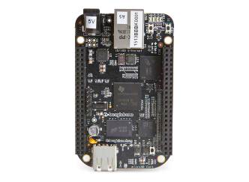

Raspberry pi Beaglebone PYNQ PSoC

**Arduino UNO:**

**Arduino Mega:**

Arduino is a widely used open-source electronics platform based on easy-to-use hardware and software. It is designed to make electronics more accessible to artists, designers, hobbyists, and anyone interested in creating interactive objects or environments.

The Arduino Uno is a popular microcontroller board used in a variety of electronics projects. It is based on the ATmega328P microcontroller and features 14 digital input/output pins, 6 analog inputs, a 16 MHz quartz crystal, a USB connection, a power jack, an ICSP header, and a reset button. The board is versatile, easy to use, and can be programmed using the Arduino IDE (Integrated Development Environment), making it a great choice for beginners and advanced users alike.

**Features:**

* Variety of boards: Arduino offers several models, such as Arduino Uno, Mega, Nano, and Leonardo, each tailored to different project requirements.
* Microcontroller: Most Arduino boards are based on the AT mega microcontroller family.
* I/O pins: Includes digital and analog I/O pins that can be connected to various sensors, LEDs, motors and other components.
* USB interface: For programming and power supply.
* Shields: Expansion boards (shields) can be plugged into the main board to add functionalities like GPS, Wi-Fi, motor control, etc.

**Programming:**

* Arduino IDE: The primary programming environment is the Arduino IDE, which used a simplified version of C/C++, simplifying the coding process.
* Community support: Extensive community support with many tutorials, forums, and pre-written code examples.

**Typical Uses:**

* Prototyping electronic devices.
* Educational projects to teach electronics and programming.
* DIY electronics projects.
* Internet of things (IoT) projects.

**MOSFET**

The MOSFET (Metal Oxide Semiconductor Field Effect Transistor) transistor is a semiconductor device that is widely used for switching purposes and for the amplification of electronic signals in electronic devices. A MOSFET is either a core or integrated circuit where it is designed and fabricated in a single chip because the device is available in very small sizes. The introduction of the MOSFET device has brought a change in the domain of switching in electronics.

A MOSFET is a four-terminal device having source(S), gate (G), drain (D) and body (B) terminals. In general, the body of the MOSFET is in connection with the source terminal thus forming a three-terminal device such as a field-effect transistor. MOSFET is generally considered as a transistor and employed in both the analog and digital circuits.

From the above MOSFET structure, the functionality of MOSFET depends on the electrical variations happening in the channel width along with the flow of carriers (either holes or electrons). The charge carriers enter the channel through the source terminal and exit via the drain. The width of the channel is controlled by the voltage on an electrode which is called the gate, and it is located in between the source and the drain. It is insulated from the channel near an extremely thin layer of metal oxide. The MOS capacity that exists in the device is the crucial section where the entire operation is across this.

A MOSFET has two classifications:

1. **Depletion Type MOSFET:**

In this type of MOSFET, channel is present from the beginning which means conduction of current is there.

1. **Enhancement type MOSFET:**

In this type of MOSFET, no channel is present from the beginning and hence no current flows. But when the positive voltage is applied more than the threshold voltage, it leads to an enhancement of a channel between the drain and source due to the gate voltage and thus it results in the conductivity of device.

They are mostly used in digital applications.

**Working principle of MOSFET:**

MOSFET is a type of transistor in which conductivity depends upon the semiconductor channel across the drain and source terminal. This semiconductor channel may be p-channel or n-channel depending upon the configuration of the MOSFET.

A MOSFET consists of three terminals- drain, source and gate. By applying some voltage across gate and source, there forms an inversion layer or a channel between the drain and source if the voltage is threshold voltage. (Threshold voltage is the minimum required voltage for the conduction of current). If the applied voltage is less than the threshold voltage, no channel is formed. Hence the current cannot flow in the MOSFET. This situation is called the Cutoff region (OFF). And after a certain level of voltage, the current becomes constant in the MOSFET. This condition is called saturation point. MOSFET is a voltage-controlled device so the thickness of channel and the amount of current depends upon the voltage applied across gate and source. If more voltage is applied, the width of channels increases and a larger amount of current able to flow through the device.

**Operating Regions of MOSFET:**

1. Cutoff region: In this region of MOSFET, no current flows as the voltage applied in the MOSFET is less than the threshold voltage resulting in the failure of formation of oxide layer. State is OFF.
2. Saturation region: In this region of MOSFET, a constant amount of current flows between the drain and source because of the threshold voltage. The state of MOSFET is ON in this case.
3. Triode/ohmic region: It is known as a partially conducting state. It is not fully on but there is a channel for current flow. The voltage here is moderate.

**P-channel MOSFET:**

The P- channel MOSFET has a P- Channel region located in between the source and drain terminals. It is a four-terminal device having the terminals as gate, drain, source, and body. The drain and source are heavily doped p+ region, and the body or substrate is of n-type. The flow of current is in the direction of positively charged holes. When we apply the negative voltage with repulsive force at the gate terminal, then the electrons present under the oxide layer are pushed downwards into the substrate. The depletion region populated by the bound positive charges which are associated with the donor atoms. The negative gate voltage also attracts holes from the p+ source and drains region into the channel region.

**N- Channel MOSFET:**

The N-Channel MOSFET has an N- channel region located in between the source and drain terminals. It is a four-terminal device having the terminals as gate, drain, source, body. In this type of Field Effect Transistor, the drain and source are heavily doped n+ region, and the substrate or body are of P-type. The current flow in this type of MOSFET happens because of negatively charged electrons. When we apply the positive voltage with repulsive force at the terminal gate then the holes present under the oxide layer are pushed downward into the substrate. The depletion region is populated by the bound negative charges which are associated with the acceptor atoms. Upon the reach of electrons, the channel is formed. The positive voltage also attracts electrons from the n+ source and drain regions into the channel. Now, if a voltage is applied between the drain and source the current flows freely between the source and drain and the gate voltage controls the electrons in the channel. Instead of positive voltage if we apply negative voltage then a hole channel will be formed under the oxide layer.

**Practical Switch Characteristics:**

As the world is not just stuck to ideal applications, the functioning of MOSFET is even applicable for practical purposes. In the practical scenario, the device should hold the properties below.

* In the ON condition, the power managing abilities should be limited which means that the flow of conduction current must be restricted.
* In the OFF state, blocking voltage levels should not be limited.
* Turning ON and OFF for finite times restricts the limiting speed of the device and even limits the functional frequency.
* In the ON condition of the MOSFET device, there will be minimal resistance values where this results in the voltage drop in forwarding bias. Also, there exists finite OFF state resistance that delivers reverse leakage current.
* When the device is performing in practical characteristics, it loses power for ON and OFF conditions. This happens even in the transition states too.

**Applications for MOSFET:**

* Amplifiers: MOSFETs are used as amplifiers in order to amplify weak signals.
* Switching power supplies: They are used as switches because they can alter power supply efficiently.
* Digital logic gates: They are used to build logic gates such as NAND, NOR etc.
* Voltage regulators: They are used as voltage regulators because they can control the amount of voltage.

**Thermistor**

A thermistor is a resistance thermometer, or a resistor whose resistance is dependent on temperature. The term is a combination of “Thermal” and “resistor”. It is made of metallic oxides, pressed into a bead, disk, or cylindrical shape and then encapsulated with an impermeable material such as epoxy or glass. There are two types of thermistors: Negative Temperature coefficient (NTC) and Positive Temperature coefficient (PTC). With an NTC thermistor, when the temperature increases, resistance decreases. Conversely, when temperature decreases, resistance increases. This type of thermistor is used the most. A PTC thermistor works a little differently. When the temperature increases, the resistance increases, and when temperature decreases, resistance decreases. This type of thermistor is generally used as a fuse. Typically, a thermistor achieves high precision within a limited temperature range of about 50 ºC around the target temperature. This range is dependent on the base resistance.

Thermistors are easy to use, inexpensive, sturdy, and respond predictably to changes in temperature. While they do not work well with excessively hot or cold temperatures, they are the sensor of choice for applications that measure temperature at a desired base point. They are ideal when very precise temperatures are required.

Some of the most common uses of thermistors are in digital thermometers, in cars to measure oil and coolant temperatures, and in household appliances such as ovens and refrigerators, but they are also found in almost any application that requires heating or cooling protection circuit for safe operation.

For more sophisticated applications, such as laser stabilization detectors, optical blocks, and charged devices, the thermistor is built in.

For example, a 10 kΩ thermistor is the standard that is built into laser packages.

**Construction**: Physically, thermistors are made by compressing mixtures of compounds usually oxides of manganese, cobalt, calcium, uranium, iron, zinc, titanium, aluminum and magnesium. This starts out in a powder form, and the material can be formed into rods, beads or discs, by a process called sintering. This is merely a process of forming a blob of material under high pressure and temperature. Wire leads can be attached to the thermistor, and sometimes it is enclosed in an envelope of some king, glass for example. Fig.3 shows various shapes in which thermistors are commercially available. The thermistor provided with this training board is a bead type.

Various types of commercially available thermistors

**Working of thermistors:**

A thermistor does not actually “read” anything, instead the resistance of a thermistor changes with temperature. How much the resistance changes depends on the type of material used in the thermistor. The resistance follows an exponential variation with temperature which is given by the following relation:

Where,

R˳= Resistance of the thermistor at T˳

T = Temperature

β = An experimental constant that can have a value between 3500-4500° K.

Unlike other sensors, thermistors are nonlinear, meaning the points on a graph representing the relationship between resistance and temperature will not form a straight line. The location of the line and how much it changes is determined by the construction of the thermistor. A typical thermistor graph looks like this:

The characteristics show that even for a small change in temperature the change in resistance of a thermistor is very large. The characteristics of thermistor are no doubt non-linear, but a linear approximation of the resistance temperature curve can be obtained over a small range of temperatures. Thus for a small limited range of temperature the resistance of a thermistor varies as:

The Steinhart and Hart equation is an empirical expression that has been determined to be the best mathematical expression for the resistance - temperature relationship of a negative temperature coefficient thermistor. It is usually found explicit in T where T is expressed in degrees Kelvin.

Where

T = Temperature in degrees Kelvin

ln R is the Natural Log of the measured resistance of the thermistor

A, B and C are constants. The coefficients A, B and C are found by taking the resistance of the thermistor at three temperatures and solving three simultaneous equations.

**Task assigned:**

To construct closed loop temperature control using PID and arduino.

**WORKING PRINCIPLE I**

To measure Rt characteristics of a thermistor and to construct a linearized temperature sensor.

**Components required:**

1. Microcontroller: Arduino UNO has been used for input and output data.
2. Thermistor: temperature sensor whose resistance varies with temperature.
3. Breadboard
4. Connecting wires

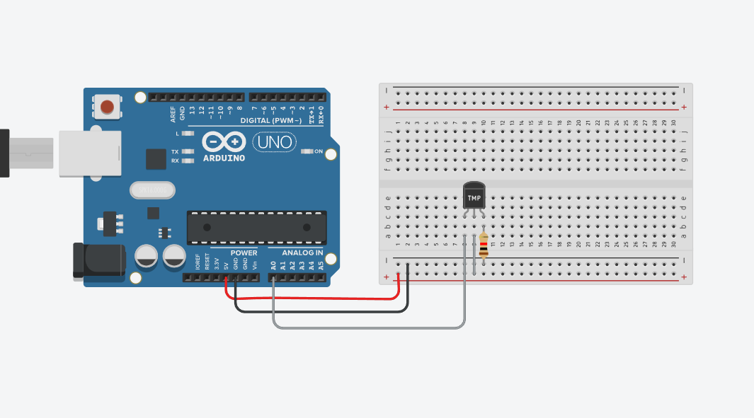

**Operation Steps:**

1. Initialization: The microcontroller initializes and provides some current to the voltage divider circuit.
2. The thermistor is connected to a 5V from the Arduino supply and the GND terminal is connected to the resistance of 10kΩ.
3. From the middle of both the thermistor and resistor comes a connection which goes to one of the analog inputs of the microcontroller Arduino UNO, suppose A0.
4. The Arduino is then programmed for the thermistor to take the ADC value.
5. According to the ADC count it is then converted to voltage.
6. After taking out the voltage the thermistor resistance is calculated using the Steinhart – hart equation.

**Advantages:**

1. Precise as thermistor show higher deflection in resistance for small changes in the temperature.
2. Can be adapted to various thermistor types and temperature ranges.

**Conclusion:**

This system forms a open loop system to accurately measure the temperature using a thermistor and to construct a linearized temperature sensor.

**Project program for Arduino:**

#include <math.h>

#define thermistorpin A0

//Steinhart-hart coefficient

const float A = 0.001129148;

const float B = 0.000234125;

const float C = 8.76741e-8;

double Thermistor(int RawADC){

 double tempK, tempC, lnR;

 lnR = log(10000.0 * ((1024.0 / RawADC - 1)));

 tempK = 1 /(A + B * lnR + C * pow(lnR, 3));

 tempC = tempK - 273.15;

 return temp_C;

}

void setup() {

  Serial.begin(9600);

}

void loop() {

  int tempval = analogRead(thermistorpin);

  Serial.print("The temperature is: ");

  Serial.print(Thermistor(tempval));

  Serial.println("°C");

  delay(100);

}

**PWM Controller**

Pulse-width modulation, commonly known as PWM, is a modulation method that changes the pulse signal’s width in electrical systems to regulate the average power supplied to a load. PWM is particularly helpful for effectively regulating the output of audio amplifiers, the speed of motors, and the brightness of light. They are frequently Used in microcontrollers and specialist PWM controller integrated circuits (ICs).

**Generation of PWM:**The PWM Generation can be explained as:

* A comparator is used to create a signal that modulates pulse width. One component of the comparator’s input is the modulating signal, while the other component is either a sawtooth wave or a non-sinusoidal wave. The comparator creates an output waveform of a PWM signal after comparing two signals.
* One possible output of a monostable multivibrator is a PWM signal. When an external trigger is applied, a monostable multivibrator will only produce one output pulse and have one stable state. An operational amplifier comparator can be used to build a monostable multivibrator circuit.
* One portion of the input to the comparator is structured by the modulating signal, and the other portion is wave formed non-sinusoidally. After analyzing two signals, the comparator generates a PWM signal as the output waveform. The output is in a “High” condition when the sawtooth or non-sinusoidal signal exceeds the modulating signal.

**Important parameters associated with PWM signal**

Duty Cycle of PWM

The duty cycle of a PWM (Pulse Width Modulation) signal is the percentage of one period in which a signal is active (or high). It is a way to describe how long a signal is on compared to how long it is off within each cycle.

Mathematically the duty cycle is given by the formula :

Duty cycle (%) =

Frequency of PWM

The frequency of a PWM (Pulse Width Modulation) signal is the number of times the PWM signal completes a cycle per second. It is measured in Hertz (Hz). The frequency is the inverse of the time period (T) , which is the duration of one complete cycle of the PWM signal.

**Application of PWM:**

PWM (Pulse Width Modulation) is widely used in various applications due to its efficiency and simplicity. Some common applications include:

1. Motor Control: PWM is used to control the speed and torque of DC motors and stepper motors by varying the average voltage supplied to the motor.
2. LED dimming: PWM adjusts the brightness of LEDs by varying the duty cycle, which controls the amount of time the LEDs are on versus off.
3. Power delivery: PWM is used in power supplies and voltage regulators to control the output voltage and deliver power efficiently.
4. Audio amplification: PWM is employed in Class D audio amplifiers to convert an analog signal into a high frequency PWN signal which can be filtered back into an analog signal for driving speakers.
5. Signal Generation: PWN can generate analog signals from digital microcontrollers by adjusting the duty cycle of the digital output.
6. Communication: PWN can encode information for transmission in communications systems, such as IR remote controls.
7. Heating Control: PWN controls the power supplied to heating elements in applications like soldering irons and electric heaters, providing precise temperature control.
8. Battery Charging: PWN is used in battery chargers to regulate the charging current and voltage, improving efficiency and prolonging battery life.

**PID Controller**

A proportional–integral–derivative controller (PID controller or three-term controller) is a control loop mechanism employing feedback that is widely used in industrial control systems and a variety of other applications requiring continuously modulated control. A PID controller continuously calculates an error value e(t) as the difference between a desired setpoint (SP) and a measured process variable (PV) and applies a correction based on proportional, integral, and derivative terms (denoted P, I, and D respectively), hence the name.

PID systems automatically apply accurate and responsive correction to a control function. An everyday example is the cruise control on a car, where ascending a hill would lower speed if constant engine power were applied. The controller's PID algorithm restores the measured speed to the desired speed with minimal delay and overshoots by increasing the power output of the engine in a controlled manner.

**PROPORTIONAL TERM :**

The proportional term (sometimes called gain) makes a change to the output that is proportional to the current error value. The proportional response can be adjusted by multiplying the error by a constant Kp, called the proportional gain.

Mathematically it is given by :

Where,

Pout = Proportional term of output

Kp = Proportional gain

e : Error

t : Time or instantaneous time (the present)

A high proportional gain results in a large change in the output for a given change in the error. If the proportional gain is too high, the system can become unstable .In contrast, a small gain results in a small output response to a large input error, and a less responsive (or sensitive) controller. If the proportional gain is too low, the control action may be too small when responding to system disturbances.

**INTEGRAL TERM:**

The contribution from the integral term (sometimes called reset) is proportional to both the magnitude of the error and the duration of the error. Summing the instantaneous error over time (integrating the error) gives the accumulated offset that should have been corrected previously. The accumulated error is then multiplied by the integral gain and added to the controller output. The magnitude of the contribution of the integral term to the overall control action is determined by the integral gain, Ki.

Mathematically it is given by :

Where,

Iout : Integral term of outputKi : Integral gain, a tuning parametere : Errort : Time or instantaneous time (the present)

The integral term (when added to the proportional term) accelerates the movement of the process towards set point and eliminates the residual steady-state error that occurs with a proportional only controller. However, since the integral term responds to accumulated errors from the past, it can cause the present value to overshoot the set point value (cross over the set point and then create a deviation in the other direction). For further notes regarding integral gain tuning and controller stability, see the section on loop tuning.

**DERIVATIVE TERM :**

The rate of change of the process error is calculated by determining the slope of the error over time (i.e., its first derivative with respect to time) and multiplying this rate of change by the derivative gain Kd. The magnitude of the contribution of the derivative term (sometimes called rate) to the overall control action is termed the derivative gain, Kd.

The derivative term is given by:

Where,Dout: Derivative term of outputKd: Derivative gain, a tuning parametere: Errort: Time or instantaneous time (the present)

The derivative term slows the rate of change of the controller output and this effect is most noticeable close to the controller set point. Hence, derivative control is used to reduce the magnitude of the overshoot produced by the integral component and improve the combined controller-process stability. However, differentiation of a signal amplifies noise and thus this term in the controller is highly sensitive to noise in the error term and can cause a process to become unstable if the noise and the derivative gain are sufficiently large. Hence an approximation to a differentiator with a limited bandwidth is more commonly used. Such a circuit is known as a Phase-Lead compensator.

**Summary of PID controller:** The proportional, integral, and derivative terms are summed to calculate the output of the PID controller. Defining u(t) as the controller output, the final form of the PID algorithm is:

Where the tuning parameters are:Proportional gain, Kp :Larger values typically mean faster response since the larger the error, the larger the proportional term compensation. An excessively large proportional gain will lead to process instability and oscillation.

Integral gain, Ki :Larger values imply steady state errors are eliminated more quickly. The trade-off is larger overshoot: any negative error integrated during transient response must be integrated away by positive error before reaching steady state.

Derivative gain, Kd :Larger values decrease overshoot, but slow down transient response and may lead to instability due to signal noise amplification in the differentiation of the error.

**Controller Effects:**

A proportional controller (P) reduces error responses to disturbances but still allows a steady-state error. When the controller includes a term proportional to the integral of the error (I), then the steady state error to a constant input is eliminated, although typically at the cost of deterioration in the dynamic response. Derivative control makes the system better damped and more stable.

**WORKING PRINCIPLE II**

Temperature control using PID controller on Arduino

**Components required:**

1. Microcontroller: Arduino UNO has been used for the input and output of data.
2. Heater: A heating element to provide controlled temperature changes.
3. Thermistor: Temperature sensor whose resistance varies with temperature.
4. MOSFET: To control the heater current.
5. Connecting Wires

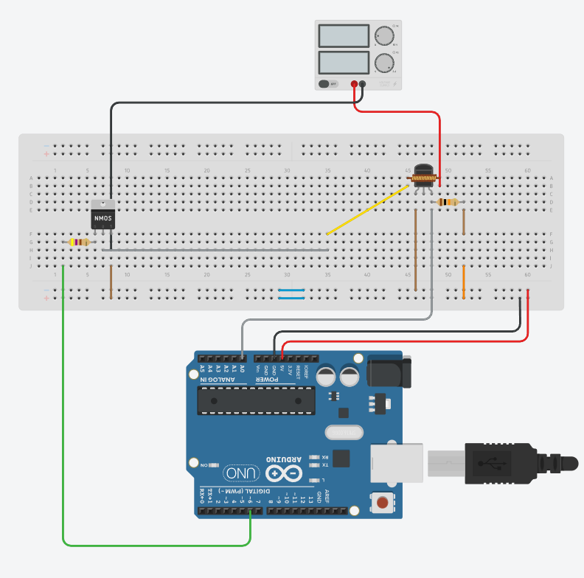

**Operating steps:**

1. Initialization: The microcontroller initializes and provides some current to a voltage divider circuit.
2. The heating element (power resistor) is connected to the external supply along with MOSFET in series.
3. The sensor/thermistor is then bought close to the heater so to sense the temperature.
4. The program then controls the heater through the MOSFET and tries to bring the present temperature of the heater closer to the set temperature.

**Conclusion:**

This system forms a closed-loop system which has a thermistor to sense the temperature according to which the heating of the heater is controlled through the MOSFET using the Arduino UNO.

**Project program for Arduino:**

#define temp_pin A0

#define control_pin 6

//PID constants

int kp = 90, ki = 30, kd = 80;

int PID_p = 0, PID_i = 0, PID_d = 0;

float PID_error;

float prev_error;

float PID_value;

//time constants

float time = 0;

float prev_time = 0;

float dt = 0;

//temperature constants

float set_temp = 50.00;

float temp_read;

//Steinhart-hart coefficient

const float A = 0.001129148;

const float B = 0.000234125;

const float C = 8.76741e-8;

float Thermistor(int RawADC){

 double temp_K, temp_C, lnR;

 lnR = log(10000.0 * ((1024.0 / RawADC - 1)));

 temp_K = 1 /(A + B * lnR + C * pow(lnR, 3));

 temp_C = temp_K - 273.15;

 return temp_C;

}

void setup() {

  Serial.begin(9600);

  pinMode(control_pin, OUTPUT);

}

void loop() {

  prev_time = time;

  time = millis();

  dt = (time - prev_time) / 1000;

  temp_read = Thermistor(analogRead(temp_pin));

  PID_error = set_temp - temp_read;

  PID_p = 0.01 * kp * PID_error;

  PID_i = 0.01 * PID_i + (ki*PID_error);

  PID_d = 0.01 * kd * ((PID_error - prev_error) / dt);

  PID_value = PID_p + PID_i + PID_d;

  if (PID_error > 0){

    PID_value = 255;

  }

  else {

    PID_value = 0;

  }

  analogWrite(control_pin, PID_value);

  prev_error = PID_error;

  Serial.print("Set Temperature: ")

  Serial.println(set_temp);

  Serial.print("Actual Temperature: ");

  Serial.println(temp_read);

  delay(250);

}

**Working Principle III**

Setting the temperature requirements using button and potentiometer

**Components required:**

1. Potentiometer: To provide the analog value to the Arduino.
2. Microcontroller: Arduino UNO has been used for the input and output of data.
3. Button: To cycle through heater working and setting temperature.
4. Thermistor: Temperature sensor whose resistance varies with temperature.
5. MOSFET: To control the heater temperature.
6. Connecting wires

**Operating steps:**

1. Initialization: The microcontroller initializes and provides some current to a voltage divider circuit.
2. The heating element (power resistor) is connected to the external supply along with MOSFET in series.
3. The sensor/thermistor is then bought close to the heater so to sense the temperature.
4. The program then controls the heater through the MOSFET and tries to bring the present temperature of the heater closer to the set temperature.
5. The button is used to cycle between the menu options of:

* Using the MOSFET circuit to heat the heating element.
* Change the set temperature for the heating element.

1. The potentiometer sends its analog value (0 to 1023) to the microcontroller which is used to define the working temperature range for the heating element, by rotating the wiper of the potentiometer the set temperature is increased or decreased.

**Conclusion:**

This system forms a closed-loop system which has a button and potentiometer to set the required temperature, a thermistor to sense the temperature according to which the heating of the heater is controlled through the MOSFET using the Arduino UNO.

**Project program for Arduino:**

#include <math.h>

#define buttonPin 2

#define thermistorPin A0

#define potPin A5

#define control_pin 6

int menuState = 0;

int lastButtonState = HIGH;

const float A = 0.001129148;

const float B = 0.000234125;

const float C = 8.76741e-8;

int setTemperature = 30;

//PID constants

int kp = 90, ki = 30, kd = 80;

int PID_p = 0, PID_i = 0, PID_d = 0;

float PID_error;

float prev_error;

float PID_value;

//time constants

float time = 0;

float prev_time = 0;

float dt = 0;

double Thermistor(int RawADC){

 double temp_K, temp_C, lnR;

 lnR = log(10000.0 * ((1024.0 / RawADC - 1)));

 temp_K = 1 /(A + B * lnR + C * pow(lnR, 3));

 temp_C = temp_K - 273.15;

 return temp_C;

}

void setup() {

  pinMode(buttonPin, INPUT_PULLUP);

  Serial.begin(9600);

}

void loop() {

  int reading = digitalRead(buttonPin);

  // Handle button press to cycle menu

  if (reading == LOW && lastButtonState == HIGH) {

    delay(50);

    if (digitalRead(buttonPin) == LOW) {

      menuState = (menuState + 1) % 2;

      Serial.print("Menu: ");

      Serial.println(menuState);

    }

  }

  lastButtonState = reading;

  // Menu 0: Read Thermistor

  if (menuState == 0) {

      prev_time = time;

      time = millis();

      dt = (time - prev_time) / 1000;

      double thermistorval = Thermistor(analogRead(thermistorPin));

      PID_error = setTemperature - thermistorval;

      PID_p = 0.01 * kp * PID_error;

      PID_i = 0.01 * PID_i + (ki*PID_error);

      PID_d = 0.01 * kd * ((PID_error - prev_error) / dt);

      PID_value = PID_p + PID_i + PID_d;

      if (PID_error < 0){

        PID_value = 0;

      }

      else{

        PID_value = 255;

      }

      analogWrite(control_pin, PID_value);

      prev_error = PID_error;

      Serial.print("Thermistor Temperature: ");

      Serial.print(thermistorval);

      Serial.print(" °C | Set Temperature: ");

      Serial.print(setTemperature);

      Serial.println(" °C");

      delay(200);

  }

  // Menu 1: Read Potentiometer

  else if (menuState == 1) {

    int potValue = analogRead(potPin);

    setTemperature = map(potValue, 0, 1023, 300, 1000) / 10.0;

    Serial.print("Setting Temperature: ");

    Serial.print(setTemperature);

    Serial.println(" °C");

    delay(200);

  }

}

**Operational-amplifier**

An operational amplifier or op-amp is simply a linear Integrated Circuit (IC) having multiple-terminals. The op-amp can be considered to be a voltage amplifying device that is designed to be used with external feedback components such as resistors and capacitors between its output and input terminals. It is a high-gain electronic voltage amplifier with a differential input and usually a single-ended output.

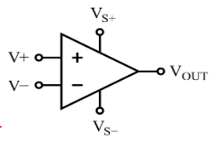

**Op-amp Circuit Construction:**

The inner schematic of a typical operational amplifier looks like this: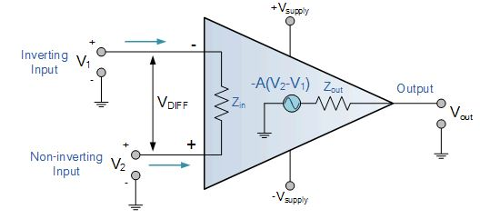

The op-amp typically has five terminals. They are listed in the following order:

* Vs+: Positive Power Supply
* Vs-: Negative Power Supply
* V+: Non-Inverting Input
* V-: Inverting Input and
* Vout: Output

The terminal with a (-) sign is called inverting input terminal and the terminal with (+) sign is called non-inverting input terminal.

The V+ and V− power supply terminals are connected to the positive and negative terminals of a DC voltage source respectively. The common terminal of the V+ and V− is connected to a reference point or ground, else twice the supply voltage may damage the op-amp.

**Types of Op-Amps:**

An op-amp has countless applications and forms the basic building block of linear and non-linear analogue systems. Some of the types of operational amplifier include:

* A **differential amplifier**, which is a circuit that amplifies the difference between two signals.
* The **instrumentation amplifier**, which is usually built from three op-amps and helps amplify the output of a transducer (consisting of measured physical quantities).
* The **isolation amplifier**, which is like an instrumentation amplifier, but having tolerance to common-mode voltages (that destroy an ordinary op-amp).
* A **negative-feedback amplifier**, which is usually built from one or more op-amps and a resistive feedback network.
* **Power amplifiers** to amplify small signals received from an input source such as microphone or antenna.

**Op-amp Parameter and Idealised Characteristic**

* **Open Loop Gain (Avo):** Ideally, the op-amp amplifies signals to the maximum extent possible. Practically, the open-loop gain varies from 20,000 to 200,000 when feedback is not used.
* **Input Impedance (Zin)**: Ideally infinite to avoid allowing current to enter the input. Actual operational amplifiers display minimal input leakage currents ranging from picoseconds to milliamperes.
* **Output Impedance (Zout)**: Ideally, zero offset voltage enables the op-amp to provide the load with full voltage. The actual output impedance varies between 100Ω and 20kΩ, restricting the voltage that can be supplied to the load.
* **Bandwidth (BW)**: Ideally infinite, which enables signal amplification at any frequency. Gain at higher frequencies is reduced by the limited bandwidth of real op-amps, which is specified by the gain-bandwidth product.
* **Offset Voltage (Vio)**: Zero is the ideal result, which occurs when both inputs are equal. In practical terms, even with equal inputs, there is a minor offset voltage that results in modest output.

**Operational Amplifier Configurations**

Two primary configurations for operational amplifiers, or op-amps, are open-loop and closed-loop. The op-amp amplifies and processes the input signal in accordance with these

arrangements.

1. **Open-Loop Configuration**:

There is no feedback between the input and the output in an open-loop setup. At its highest gain, the op-amp functions at a very high level (usually in the region of 100,000 or more).

However, this results in a very sensitive amplifier that frequently experiences output saturation. Because they lack stability and control, open-loop systems are typically impractical for linear applications.

Key Features:

* Maximum gain.
* No feedback is used.
* Suitable for comparator applications where the output toggles between high and low states.

**2. Closed-loop configuration:**

In a closed-loop system, some of the output is returned back into the system as positive or negative feedback (negative feedback is most prevalent). An op-amp with regulated output will behave predictably due to negative feedback, which aids in gain stabilization and control.

There are two types of closed-loop configurations:

1. Inverting Configuration: The non-inverting terminal is grounded, and the input signal is connected to the inverting terminal. With a 180-degree phase shift from the input, the output is inverted.
2. Non-Inverting Configuration: The non-inverting terminal receives the input signal. The output is regulated amplification of the input signal.

Key Features:

* Controlled and stable gain.
* Negative feedback improves linearity and reduces distortion.
* Commonly used in amplifiers, filters, and other signal processing circuits.

**Real vs Ideal Op-amp**

|  |  |  |
| --- | --- | --- |
| **Parameter** | **Ideal op-amp** | **Real op amp** |
| **Voltage gain** | ∞(infinity) | 10,000 to 100,000 |
| **Input Impedance** | ∞(infinity) | Very high (in the range of megaohms) |
| **Output impedance** | 0(zero) | Low but not zero |
| **Bandwidth** | ∞(infinity) | Limited (dependent on gain-bandwidth product) |
| **Power consumption** | 0(zero) | Depends on the specific op-amp model |

**Op-Amp Classification:**

1. **Dual Supply Op-Amp:**The power supplies used by a Dual Supply Op-Amp are positive and negative, respectively represented by the symbols +Vcc and -Vcc. This arrangement, which is frequently utilized in conventional analog applications, enables the output to change both positively and negatively, enabling the amplification of both positive and negative input signals.

1. **Single Supply Op-Amp:**The ground (0V) acts as the reference point for a single supply operational amplifier, which uses a single positive power supply, usually represented as +Vcc. In battery-operated, low-power devices or scenarios with a single power source, this design is frequently utilized. To function within the power supply’s voltage range, this kind of op-amp requires biasing both the input and output signals.

1. **Rail-to-Rail Op-Amp:** In order to optimize input and output voltage fluctuation and enable the output to go next to the ground and positive power supply rails, a rail-to-rail operational amplifier (Op-Amp) is constructed. Because of this capability, these op-amps can fully utilize the supply voltage, which makes them perfect for high-precision, low-voltage applications.

**Op-Amp Operation:**

Ideally, an op-amp amplifies only the difference in voltage between the two, also called differential input voltage. The output voltage of the op-amp Vout is given by the equation:

where AOL is the open-loop gain of the amplifier.

In a linear operational amplifier, the output signal is the amplification factor, known as the amplifier’s gain (A) multiplied by the value of the input signal.

**Operational Modes of Op-Amps:**

An operational amplifier, or Op-Amp, is a direct-coupled, high-gain amplifier used for integration, subtraction, and summation. This basic analog integrated circuit (IC) functions in several modes according to its intended function. These modes are explained below:

1. **Single-Ended Operation**: In order to apply the signal to the other input, one input in this mode is linked to ground. Terminal 4’s output is inverted while terminal 3’s output remains unchanged if the signal is sent to terminal 1. The output of terminal 4 is inverted if the signal is sent to terminal 2, but the output of terminal 3 remains unchanged.

1. **Differential Operation**: Both inputs get two opposed signals that are applied out of phase. By twice the signal compared to the single-ended mode, the output is stronger. A different term for this is a double-ended procedure.

1. **Common Mode Operation**: The output signals cancel each other out when the same in-phase signals are applied to both inputs, producing zero output.

1. **Inverting and Non-inverting Inputs**: Terminal 1 is the non-inverting input since a positive input result in a non-inverted output. On the other hand, terminal 2 is designated as the inverting input when positive input is applied, resulting in an inverted output.

**LM-35**

The LM35 is a precision integrated-circuit temperature sensor developed by Texas Instruments. It provides an output voltage that is linearly proportional to the Celsius temperature. Unlike thermistors, the LM35 does not require any external calibration or trimming, making it easy to use in both analog and embedded temperature sensing applications.

The sensor outputs 10 millivolts (mV) per degree Celsius, meaning at 25°C, it produces 250 mV. It operates over a temperature range of −55°C to +150°C, with a typical accuracy of ±0.5°C at room temperature. The LM35 draws only 60 µA of current, ensuring very low self-heating, which helps maintain measurement accuracy.

Due to its low cost, accuracy, and easy interfacing with microcontrollers or op-amps, the LM35 is widely used in environmental monitoring, temperature control systems, medical instruments, and consumer electronics.

**Working Principle:**

The LM35 is an analog temperature sensor that provides a voltage output directly proportional to the ambient temperature in degrees Celsius. It functions by utilizing an internal temperature-dependent voltage source and an amplifier that scales the output to a precise and linear voltage.

Internally, the LM35 contains a semiconductor junction whose voltage characteristics vary with temperature. This variation is sensed and amplified, producing an output of 10 millivolts (mV) per degree Celsius. This linear relationship allows for simple conversion from voltage to temperature without the need for complex calculations or calibration.

For instance:

* At 0°C, the output voltage is 0.00V
* At 25°C, the output voltage is 250mV
* At 100°C, the output voltage is 1.00V

This output can be fed directly into an analog-to-digital converter (ADC) in microcontroller systems, or compared using an operational amplifier in analog control systems such as closed-loop temperature controllers.

The LM35 operates efficiently with a supply voltage ranging from +4V to +30V and draws very low current (approximately 60 µA), which significantly reduces self-heating and ensures more accurate readings.

Because of its linearity, accuracy, and ease of use, the LM35 is widely used in temperature monitoring and control systems where precise analog temperature measurement is required.

**Task assigned:**

Operational Amplifier-based closed loop temperature control using Multisim.

1. LM-35 as temperature sensor:

LM-35 have a linear relationship between voltage and temperature given by

Vout = 10 mV/°C

The LM35 senses the ambient temperature and outputs a voltage linearly proportional to the temperature. The output is 10 mV per °C. For example, at 30°C, it will give 300 mV.

1. Op-amp as difference amplifier:

A differential amplifier is a fundamental op-amp configuration used to amplify the difference between two input voltages while rejecting any common-mode signals such as noise or interference. This configuration is especially important in control systems, instrumentation, and sensor interfacing, where precision and stability are critical.

The differential amplifier uses an operational amplifier with a specific resistor network that allows the output voltage to represent the difference between two inputs, V2 and V1​. The basic output equation is:

Where:

* V1: Voltage at the inverting input
* V2​: Voltage at the non-inverting input
* Ri​ and Rf​: Input and feedback resistors

1. Op-amp as PID controller:

A **PID controller** is a closed-loop feedback control system that combines **Proportional (P)**, **Integral (I)**, and **Derivative (D)** control actions to maintain a process variable (like temperature) at a desired setpoint. In analog electronics, a PID controller can be implemented using **operational amplifiers (op-amps)**, along with resistors and capacitors to perform the mathematical operations of addition, integration, and differentiation.

Function of Each PID Block:

1. Proportional (P):

* Amplifies the error signal (difference between setpoint and actual value).
* Output is directly proportional to the error.
* Implemented using a basic inverting or non-inverting amplifier.

Output:

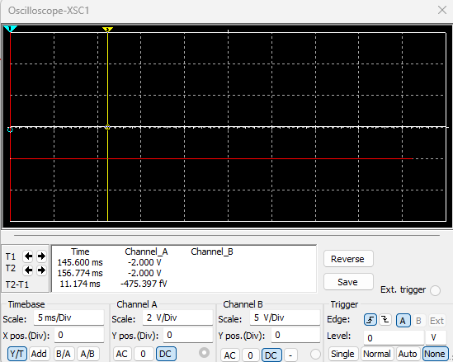

1. **Integral (I)**:

* Accumulates the error over time to eliminate steady-state error.
* Implemented using an **op-amp integrator circuit** (RC feedback with a capacitor).

Output:

1. Derivative (D):

* Predicts future error based on the rate of change of the error.
* Helps reduce overshoot and improves stability.
* Implemented using an op-amp differentiator circuit.

Output:

1. Op-amp as Summing amplifier:

A summing amplifier is an important op-amp configuration that adds multiple input voltages together to produce a single output voltage. In analog signal processing and control systems, summing amplifiers are commonly used to combine signals such as Proportional (P), Integral (I), and Derivative (D) terms in a PID controller.

A basic inverting summing amplifier with an op-amp and three input voltages V1​, V2​, and V3​, uses the following configuration:

Where:

* R1 ,R2 ,R3​: input resistors
* Rf: feedback resistor
* V1 ,V2 ,V3​: input signals

Output:

1. Complete circuit:

1. Gate driver IC:

The **TC4420** is a **high-speed, high-current, single-channel MOSFET gate driver IC** manufactured by Microchip Technology. It is designed to convert logic-level input signals into high-current, fast-switching output signals suitable for driving power MOSFETs and IGBTs.

It is widely used in **motor control**, **switch-mode power supplies (SMPS)**, **DC-DC converters**, **inverters**, and other **power switching applications.**

The TC4420 acts as a buffer and amplifier between a low-current logic signal and the gate of a power MOSFET. It delivers a strong, fast, high-voltage pulse to the gate, ensuring the MOSFET switches on and off quickly.

MOSFETs like the IRFZ44N require a gate voltage of at least 10 V for full conduction, and their gate has capacitive behavior that must be charged and discharged quickly. The TC4420 provides this fast drive capability.

**References:**

* <https://www.thinksrs.com/downloads/programs/therm%20calc/ntccalibrator/ntccalculator.html>
* <https://www.tinkercad.com>
* <https://www.youtube.com/watch?v=LXhTFBGgskI&ab_channel=Electronoobs>
* <https://www.skyeinstruments.com/wp-content/uploads/Steinhart-Hart-Eqn-for-10k-Thermistors.pdf>
* <https://www.ti.com/lit/an/slva462/slva462.pdf?ts=1719773810087&ref_url=https%253A%252F%252Fwww.google.com%252F>
* <https://fscdn.rohm.com/en/products/databook/applinote/discrete/common/rthjc_measurement_and_usage_an-e.pdf>
* <https://chatgpt.com/?model=auto>
* <https://www.electronicsforu.com/technology-trends/learn-electronics/operational-amplifier-basics>
* <https://www.utmel.com/components/tc4420-mosfet-driver-datasheet-pinout-application-circuit?id=983>